The Kentucky Academy of General Dentistry Presents:
Adult Oral Conscious Sedation: Introduction and Update
Friday July 24, 2015; 7:45 am-4 pm EST.
The course will award 8 hours of CE credit. It will be held at ADL Dental Laboratory 4411 Poplar Level Rd, Louisville, KY
Please RSVP to Maegan Bennett at mbennett@agd.org or 270-401-3928 AGD Members $299 Non-members $399

With oral sedation dentistry, both your frightened and anxious patients as well as those needing extensive treatment are transformed into your most productive and high-quality visits. Learn how to apply new safe and simple protocols to alleviate your fearful patients’ anxiety as well as provide relaxation for your long dental procedures. Adult oral sedation offers many advantages to caring dentists, including completing more dentistry is a single visit, treating bigger restorative cases from patients who were previously reluctant due to anxiety, and leaving patients with little to no postoperative discomfort regardless of the procedure – resulting in more referrals.

Objectives:
- Learn how sedation dentistry can allow you to gain more restorative, cosmetic, endodontic, and implant cases
- Discuss how to adjust the level of sedation to fit your patient’s comfort as well as your technical needs
- Discover why what you don’t know can harm your patient
- Learn reasons why oral sedation is a safe procedure
- Learn seven factors you must know to confidently deliver sedation dentistry
- Understand which patients are appropriate for sedation and which are not
- Discuss how to provide maximum safety for both patient and practitioner

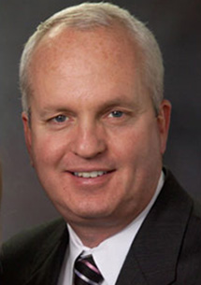Dr. Anthony Feck graduated with high distinction at the University of Kentucky College of Dentistry where he was awarded numerous achievement awards for scholastic excellence. Soon after his graduation in 1983, Dr. Feck was appointed Associate Professor of Periodontics and Restorative Dentistry at his alma mater. In private practice in Lexington, Kentucky since 1983, Dr. Feck’s has reached an extreme level of success, placing him in the top one percent of dental practitioners nationwide in several categories.

On the cutting edge of several dental technologies, Dr. Feck has served as a consultant to the development of many new innovations. He has several articles to his credit and is a highly sought-after speaker. His speaking engagements include local and state dental associations, as well as the American Dental Association and the Academy of General Dentistry.

Dr. Feck has established himself as an outstanding clinician, mentor, and educator. His passions include practice building, new technological advancements, and managing high-fear patients. Seeking a way to treat the startling number of people refusing to seek dental care due to dental phobia, fear, and anxiety,

Dr. Feck co-founded DOCS Education, the world’s leading provider of continuing education courses in sedation dentistry, with Dr. Michael Silverman in 1999. He has played a major role overseeing DOCS Education’s growth and currently serves as the organization’s Dean of Education.

His expertise in business lead Dr. Feck to found Sunrise Dental Solutions (SDS), a business solutions and consulting firm that helps manage some of the most successful dental practices in North America. He has developed several models to assist dentists in their professional growth including “The Ultimate Team” series, “Own Your Market,” and “Solution Yes.”

To register, call Maegan Bennett– 270-401-3928 or mail completed form to Kentucky AGD- 950 N. Mulberry Suite 170- Elizabethtown, KY 42701

Name_________________________________________________________

Please Circle One: DMD DDS MD PHD OTHER AGD ID # _______________________

Mailing Address _______________________________________________________

City, State_____________________________________________ Zip ____________

E-Mail __________________________________Telephone____________________
PAYMENT METHOD (Payment is due at time of registration. Payment may be made by check, MasterCard or Visa).

Credit Card Number__________________________________________________

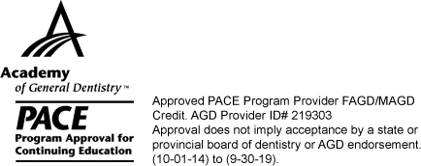Exp. Date___________ Security Code_____________

Credit Card Holder Name_________________________________________________

Total Amount Enclosed $ _______ Check Number ______ (make check payable to the KyAGD)

